**PRACTICAL – 9**

**Implementation of K Mean Clustering and un-clustering on jupyter Notebook using Python.**

**Step 1**

import matplotlib.pyplot as plt

import pandas as pd

import seaborn as sns

iris = sns.load_dataset('iris')

labels = iris.species.unique()

iris.head()

**output**

|  | **sepal_length** | **sepal_width** | **petal_length** | **petal_width** | **species** |  |
| --- | --- | --- | --- | --- | --- | --- |
| 0 | 5.1 | 3.5 | 1.4 | 0.2 | setosa |  |
| 1 | 4.9 | 3.0 | 1.4 | 0.2 | setosa |  |
| 2 | 4.7 | 3.2 | 1.3 | 0.2 | setosa |  |
| 3 | 4.6 | 3.1 | 1.5 | 0.2 | setosa |  |
| 4 | 5.0 | 3.6 | 1.4 | 0.2 | setosa |  |

**Step 2**

iris["species"] = pd.Categorical(iris["species"])

iris["species"] = iris["species"].cat.codes

iris.head()

**Output**

|  | **sepal_length** | **sepal_width** | **petal_length** | **petal_width** | **species** |  |
| --- | --- | --- | --- | --- | --- | --- |
| 0 | 5.1 | 3.5 | 1.4 | 0.2 | 0 |  |
| 1 | 4.9 | 3.0 | 1.4 | 0.2 | 0 |  |
| 2 | 4.7 | 3.2 | 1.3 | 0.2 | 0 |  |
| 3 | 4.6 | 3.1 | 1.5 | 0.2 | 0 |  |
| 4 | 5.0 | 3.6 | 1.4 | 0.2 | 0 |  |

**Step 3**

X = iris[['sepal_length','sepal_width']].values

y = iris.species

from sklearn.cluster import KMeans

model = KMeans(n_clusters = 3).fit(X)

centers = model.cluster_centers_

new_labels = model.labels_

print('Centroids :',centers)

**output**

Centroids : [[5.006 3.428 ]

[6.81276596 3.07446809]

[5.77358491 2.69245283]]

**Step 4**

print('\nLabels :',new_labels)

**output**

Labels : [0 0 0 0 0 0 0 0 0 0 0 0 0 0 0 0 0 0 0 0 0 0 0 0 0 0 0 0 0 0 0 0 0 0 0 0 0

0 0 0 0 0 0 0 0 0 0 0 0 0 1 1 1 2 1 2 1 2 1 2 2 2 2 2 2 1 2 2 2 2 2 2 2 2

1 1 1 1 2 2 2 2 2 2 2 2 1 2 2 2 2 2 2 2 2 2 2 2 2 2 1 2 1 1 1 1 2 1 1 1 1

1 1 2 2 1 1 1 1 2 1 2 1 2 1 1 2 2 1 1 1 1 1 2 2 1 1 1 2 1 1 1 2 1 1 1 2 1

1 2]

**Step 5**

plt.figure(figsize=(12,8))

plt.scatter(X[:, 0], X[:, 1],c=y, s=60)

plt.xlabel('Sepal length', fontsize=18)

plt.ylabel('Sepal width', fontsize=18)

plt.title('Unclustered Data',fontsize=18)

**output**

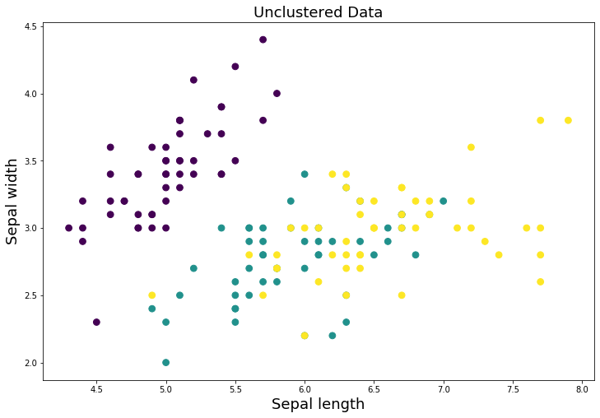

**Step 6**

plt.figure(figsize=(12,8))

plt.scatter(X[:, 0], X[:, 1], c=new_labels,s=60)

plt.scatter(centers[:, 0], centers[:, 1], c='r', s=400, marker = '*', zorder=10);

plt.xlabel('Sepal length', fontsize=18)

plt.ylabel('Sepal width', fontsize=18)

plt.title('Clustered Data',fontsize=18)

**output**

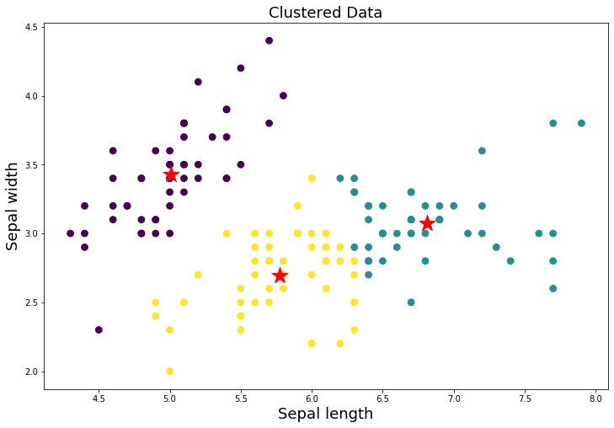

**Step 7**

y_pred = model.predict([[2.3,5.6]])

print("Result :",labels[y_pred[0]])

**Result : setosa**